Activity: • Configure Jenkins to install MAVEN • Steps: • Go to Manage Jenkins -> Global Tool configuration -> Maven. Provide the installation name and select the version for automatic install. • Definition of Done: • None

Click manage Jenkins

Select Global tool configuration

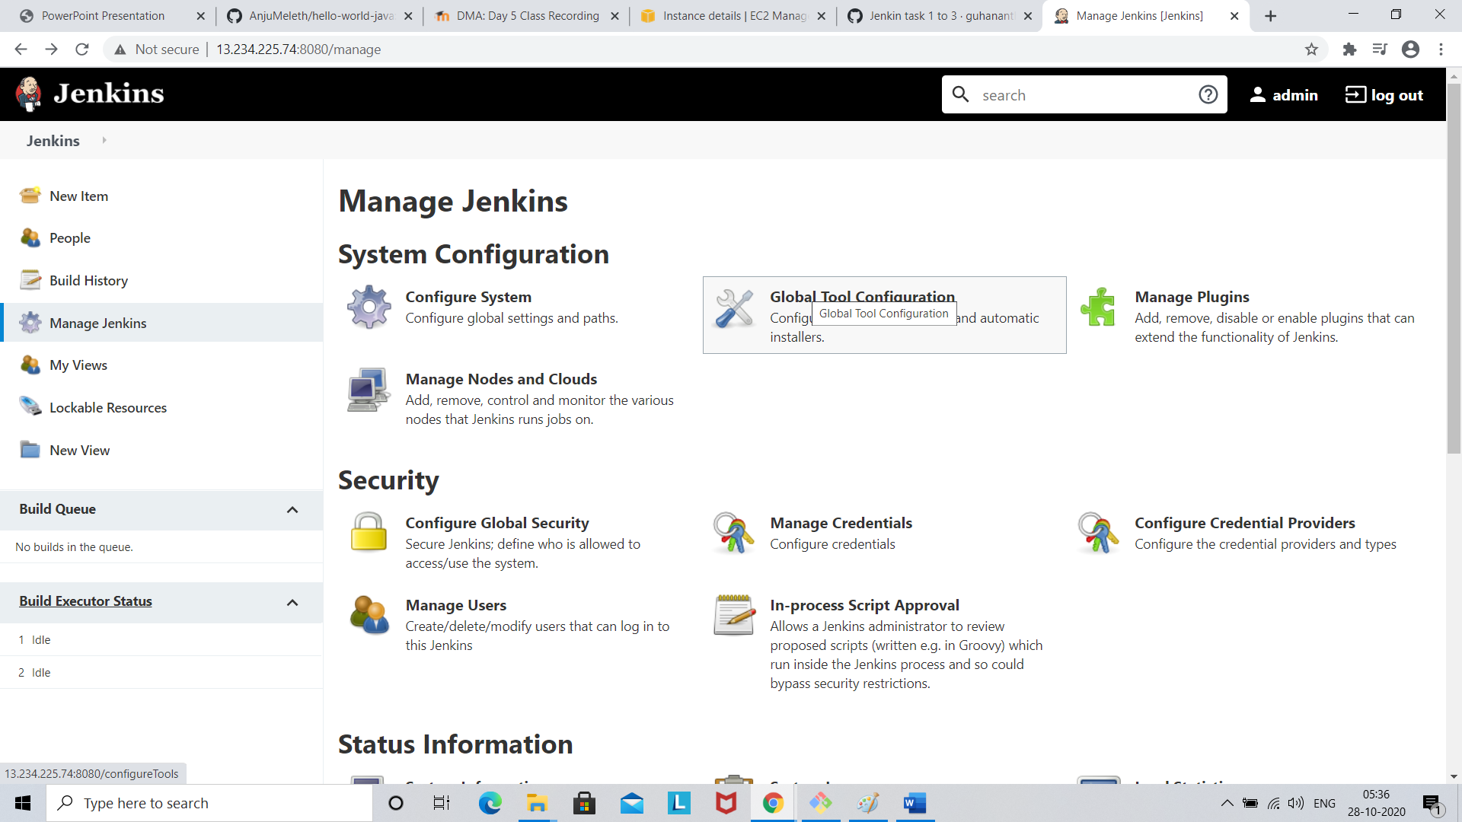

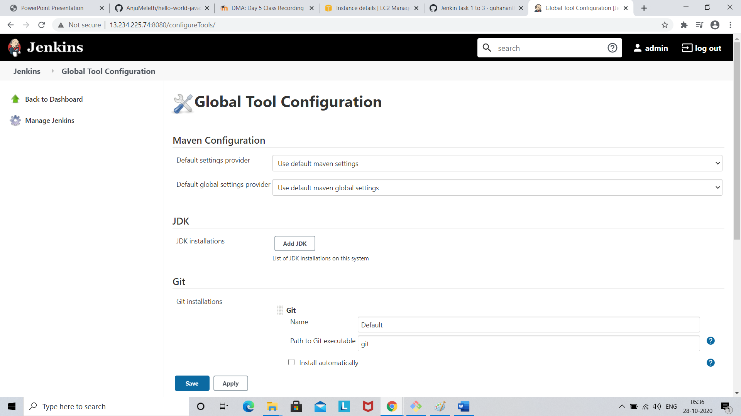

Go to Maven

Click add Maven

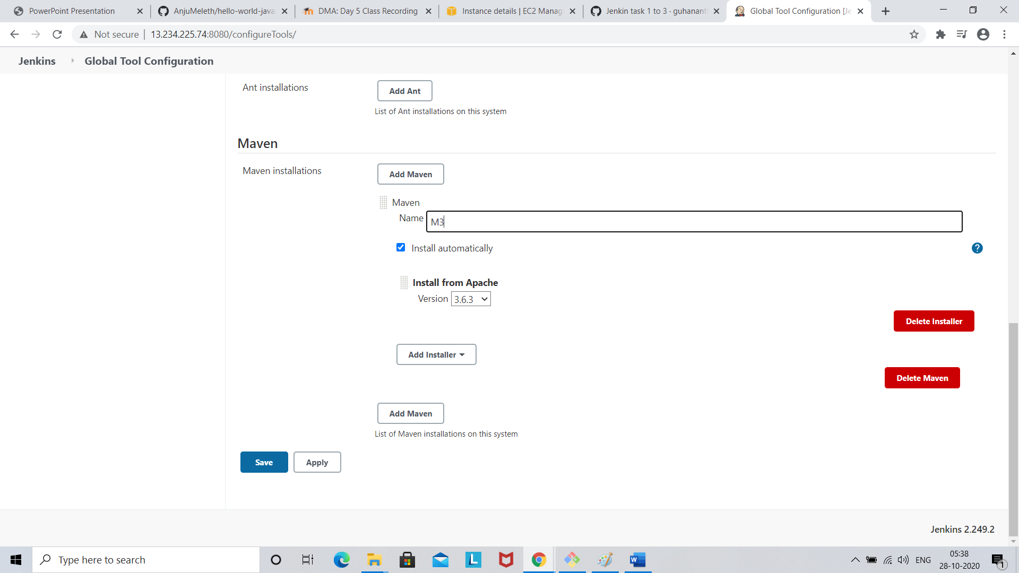

Click save